Lab 3 – Advanced Dart Practice Exercises
1. Objective
This lab helps students strengthen their understanding of advanced Dart features—including asynchronous programming, streams, microtasks, JSON handling, and factory constructors—by completing five hands-on exercises that can run directly on DartPad or in Android Studio / VS Code.
2. Requirements
Complete five mini-projects demonstrating advanced Dart concepts:
- Product Model & Repository – build a data model and a repository with both Future and Stream behaviors.
- User Repository with JSON – simulate fetching and parsing JSON data from an API.
- Async + Microtask Debugging – illustrate event-loop and microtask order.
- Stream Transformation – apply functional operations such as map() and where() to a stream.
- Factory Constructors & Cache – demonstrate singleton and factory patterns.
All tasks must:
- Execute without error in DartPad or Flutter’s integrated Dart runtime.
- Include brief inline comments explaining logic and expected output.
- Print key results to the console.
3. Guided Steps
Exercise 1 – Product Model & Repository
Goal: Understand Futures and Streams.
- Define Product { id, name, price }.
- Implement ProductRepository with:
- Future<List<Product>> getAll()
- Stream<Product> liveAdded() for real-time updates.
- Use StreamController.broadcast() to emit new items.
- Print results to console.
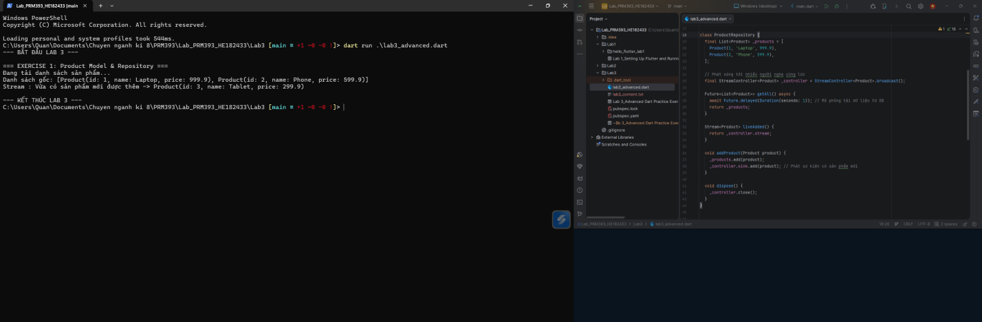
Exercise 2 – User Repository with JSON
Goal: Practice JSON serialization / deserialization.
- Create User { name, email } and User.fromJson(Map) constructor.
- Simulate JSON list from an API.
- Use Future<List<User>> to return parsed data.
- Display results with print().
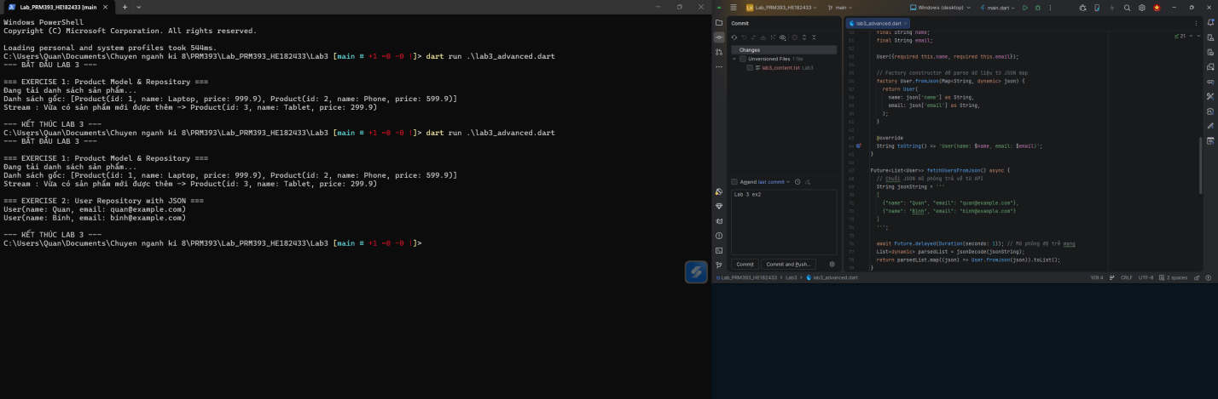
Exercise 3 – Async + Microtask Debugging
Goal: Differentiate microtask and event queues.
- Write a snippet with scheduleMicrotask() and Future(() {…}).
- Print execution order.
- Explain why microtasks run before event callbacks.
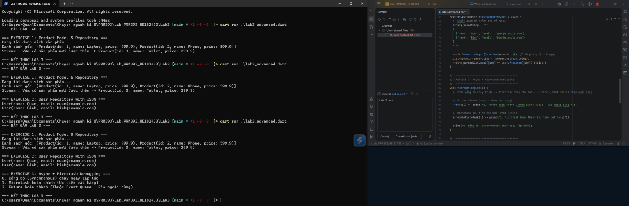
Exercise 4 – Stream Transformation
Goal: Use functional stream operators.
- Create a stream of numbers 1–5.
- Transform values to their squares using map().
- Filter even numbers with where().
- Listen and print each emitted value.
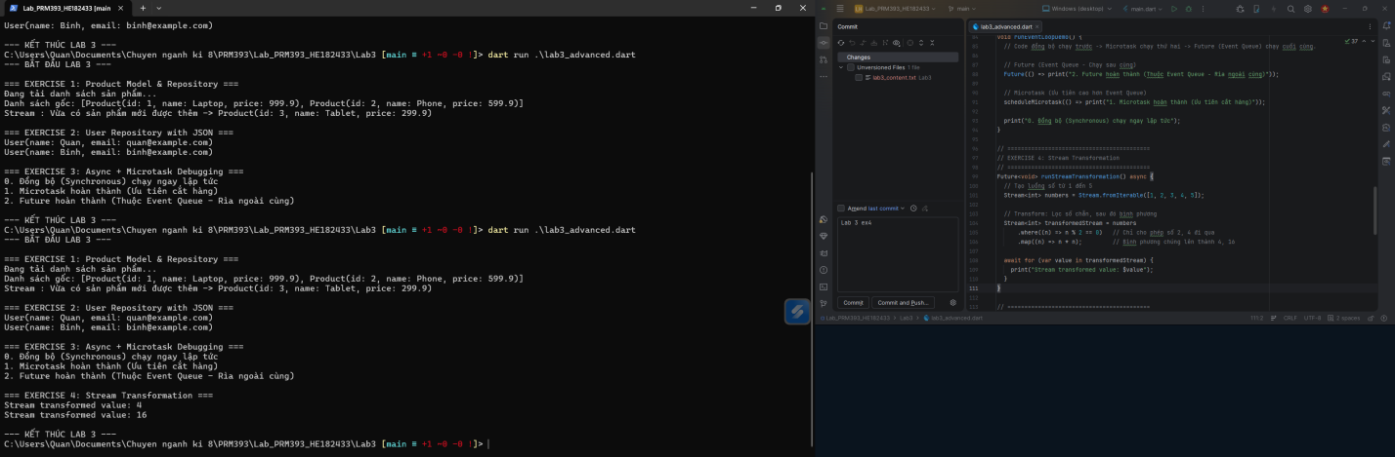
Exercise 5 – Factory Constructors & Cache
Goal: Show how factory constructors implement caching.
- Create a Settings class with private constructor.
- Add a factory Settings() that returns a singleton instance.
- Verify two instances refer to the same object (identical(a, b) → true).
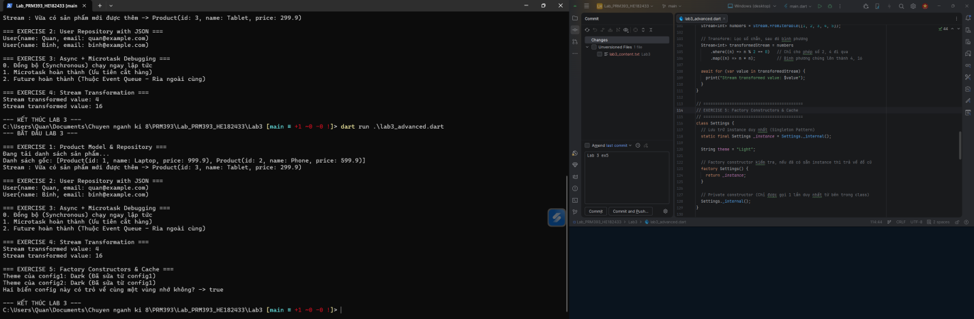
4. Expected Results
- Each exercise compiles and prints its output in order.
- Console shows proper stream events, microtask execution sequence, and singleton confirmation.
- Students understand how to handle asynchronous flows and object creation patterns in Dart.
5. Submission
- Deliverable: Single Dart file or zipped project containing five completed exercises.
- Evaluation Criteria:
  - Correct implementation and syntax (40%)
  - Code clarity and comments (20%)
  - Output accuracy (20%)
  - Use of async / stream features (20%)

